Final Spring Runners DevLog

General Disclaimer

Digital Prototype (4/17 - 5/1)

Jeffrey (16.35 Hrs total)

4/18 - 5/1 [6.75 hrs] (In class and in team meetings)

4/22 - 1.5hrs worked today (8.25 hrs cumulative total)

4/24 - 1hr (9.25 hrs cumulative total)

4/26 - 1hr (10.25 hrs cumulative total)

4/26 - 1.25hrs (11.5 hrs cumulative total)

4/27 - 1hr (12.5 hrs cumulative total)

4/28 - 1.5hrs (14 hrs cumulative total)

4/28 - 2.25hrs (16.25 hrs cumulative total)

5/1 - 0.1hrs (Digital Prototype presentation) (16.35 hrs cumulative total)

Malachi [18.5 Hours Total]

4/18 - 5/1 [6 hours] (In class and in team meetings)

4/18 [1 hour]

4/23 [4 Hours]

4/26 [3.5 hours]

4/27 [1 hour]

4/28 [3 hours]

Lawrence [11 hours total]

4/18 - 5/1 [6 hours] (In class and in team meetings)

4/23 [1 hour]

4/24 [2 hours]

4/30 [2 hours]

Joseph [11 Hours of Work]

April 18th - May 1st [6 hours] (In class and in team meetings)

April, 20th [5 hours]

Overview/Summary

4-17 DevLog - Brainstorming

4-19 DevLog

4-21 DevLog

4-24 DevLog

4-26 DevLog

5-1 DevLog

Alpha Playtest (5/1 - 5/8)

Jeffrey (12.5 Hrs total)

5/1-5/8 [2.5 hrs] (In class and in team meetings)

5/2 - 1 hr (cum total 3.5 hrs)

5/3 - Team meeting details (time already accounted for)

5/5 - 5.6 hours (cumulative time 9.1 hrs)

5/6 - 1.2 hrs (cumulative time 10.3 hrs)

5/7 - 1 hr (cumulative time 11.3 hrs)

5/8 - Class meeting + individual work .2 hr (cumulative time 11.5 hrs)

5/9 - 1 hr (cumulative time 12.5 hrs)

Malachi [9.5 Hours Total]

In Class [2.5 Hours]

5/5 [5 Hours]

5/8 [2 Hours]

Lawrence [11 hours]

5/3 [1 hour]

5/5 [5 hours]

5/7 [5 hours]

Joseph [10.5 Hours of Work]

May 1st - May 8th [2.5 hrs] (In class and in team meetings)

May, 5th [5 hours]

May, 7th [3 hours]

Beta Playtest (5/8 - 5/15)

Jeffrey (8.5 hrs total)

5/10 - 1 Hour individual + 1 hours team meeting (2 hrs)

5/11 - 2 hrs (Cumulative Time 4 hrs)

5/14 - 1.5 Hrs (Cumulative Time 5.5 hrs)

5/15 - 1 hr individual + 2 Hr in class (Cumulative Time 8.5 hrs)

Malachi

5/10 [2 Hours]

Lawrence [11 hours]

5/10 [5 hours]

5/13 [5 hours]

5/14 [1 hour]

Joseph [8 Hours of Work]

May, 14th [8 hours]

PostMortem Presentation (5/15 - 5/24)

Jeffrey (14 hrs total)

5/17 - 4.0 hours (inc. team meeting)

5/18 - 1 hr (5.0 hrs cumulative total)

5/19 - 2.5 hrs (7.5 hrs cumulative total)

5/20 - 1 hr (8.5 hrs cumulative total)

5/22 - 2.75 hrs (11.25 hrs cumulative total)

5/23 - 2.5 hrs (13.75 hrs cumulative total)

5/24 - 0.25 hrs (14 hrs cumulative total)

Malachi [15.5 Hours Total]

5/18 [1 Hour]

5/19 [1 Hour]

5/21 [5 Hours]

5/22 [5.5 Hours]

5/23 [3 Hours]

Lawrence [15.75 hours]

5/18 [2 hours]

5/19 [5.5 hours]

5/21 [3.75 hours]

5/22 [4.5 hours]

Joseph [15 Hours of Work]

May 19th [5.5 hours]

May 21st [4.5 hours]

May 22nd [5 hours]

Game Presentation (5/24 - 5/31)

Jeffrey (6.5 hrs total)

5/25 - .25 hrs

5/26 - .50 hrs (0.75 hrs cumulative total)

5/27 - 1.75 hrs (2.5 hrs cumulative total)

5/29 - 2.25 hrs (4.75 hrs cumulative total)

5/31 - 1.75 hrs in class (6.5 hrs cumulative total)

Malachi [6 Hours Total]

5/29 [3 Hours]

5/30 [3 Hours]

Lawrence [12.5 hours]

5/24 [2 hours]

5/27 [2.5 hours]

5/28 [3 hours]

5/30 [5 hours]

Joseph [6.5 Hours of Work]

May 24th [2 hours]

May 29th [2.5 hours]

May 30th [2 hours]

Final Deliverables (5/31 - 6/4)

Jeffrey (5.25 hrs total)

6/2 [2.25 hrs Team Meeting + .75 individual (cumulative total 3 hrs)]

6/3 - 2.25 hrs (5.25 hrs cumulative total)

Malachi [4 Hours so far]

6/2 [2 hours with group + 2 hours alone]

Lawrence [However long its taken to get the final deliverables done lol I haven’t been keeping track]

6/2 - 6/4 [At least 4 hours]

Joseph [3 Hours of Work]

June 2nd [2 hours]

June 3rd [1 hour]

# General Disclaimer

If one of the 6 areas for each DevLog entry is not addressed, assume there are no relevant changes in that area. Example, there would be no playtesting updates in the early development cycle because there was no playtesting information until later on.

# Digital Prototype (4/17 - 5/1)

## Jeffrey (16.35 Hrs total)

### 4/18 - 5/1 [6.75 hrs] (In class and in team meetings)

Worked on Devlog, brainstorming, and working with teammates to make plans, etc. See further details in the overview/summary section.

### 4/22 - 1.5hrs worked today (8.25 hrs cumulative total)

Basic setup of the project. Build initial layout. Got movement V1 working partly working (left and right only)

### 4/24 - 1hr (9.25 hrs cumulative total)

Finished movement V1, had up, down, left, right, big jump support; no ground detection.

### 4/26 - 1hr (10.25 hrs cumulative total)

Working before class with the team. We discussed and decided to shift to a different movement methodology. So, I had to scrap some parts of what I had for movement V1.

Result of Minimal progress towards movement V2.

### 4/26 - 1.25hrs (11.5 hrs cumulative total)

Now movement V2 is almost to where movement V1 was (all movements ok, no floor detection yet).

### 4/27 - 1hr (12.5 hrs cumulative total)

Adding floor detection to Movement V2. So now the player can only jump if they are touching an object that is on the “floor” layer.

### 4/28 - 1.5hrs (14 hrs cumulative total)

I found and fixed the ultra jump bug, where a w press right after a shift (spring shoe jump) would result in an ultra jump with some combination of the power from both jumps (too much), and a bug.

### 4/28 - 2.25hrs (16.25 hrs cumulative total)

Finished the prototype this work session.. Solved 2 bugs.

The first was pointed out to me by malachi from my revision 1 WebGL build that when the hero is centered over the tall thin poles, if they are dead center, he will think he is not on the ground, and will not jump; This was fixed relatively easily by adding a center detection raycast.

The second ‘bug’ I found myself, and it was if you were able to position the character so it was technically hanging off the platform (based on positions) the Unity physics would give the player a benefit of the doubt for not falling off, but because it wasn’t actually on any ground and was hovering, it would not jump. This was fixed with two changes. First, by adding more raycasts for ground detection to further narrow the range where this could occur. Second, by making the hitbox for the character have a small radius corner, they would fall down instead of hovering when no longer actually supported by the platform.

Exported to WebGL for final build, end of working on this digital prototype.

Overall, I think this prototype version is ready to go, and should be able to integrate relatively easily into the final project with all the other code. The only major dependency this really has on the other resources to make this work correctly is that any floor that this needs to land on and jump from must be placed in the floor layer, which should be easy to accommodate.

### 5/1 - 0.1hrs (Digital Prototype presentation) (16.35 hrs cumulative total)

Presented in class. Functioned as expected. Classroom feedback to this and our other prototypes was positive overall.

## Malachi [18.5 Hours Total]

### 4/18 - 5/1 [6 hours] (In class and in team meetings)

Worked on Devlog, brainstorming, and working with teammates to make plans, etc.

### 4/18 [1 hour]

Compiled images and sounds as inspiration for the direction the game would go.

<https://docs.google.com/presentation/d/1qwQIpSgeRli2ufGVeoVFNV7zqfQ26D1ML-yjLhj4Nwg/edit?usp=sharing>

### 4/23 [4 Hours]

Researched music programs, found the program called famitracker and composed some original song ideas to build on later.

### 4/26 [3.5 hours]

Used the 100 mechanics grappling hook 2D to build basic prototype.Took about an hour and a half to figure out how to get the grappling hook to grab to a specific gameobject instead of where the mouse clicks. [ 1.5 hours ]

* I then added a radius so that the player has to be within a certain distance of the grapple block in order to swing on it. [ 1 hour ]
* Next, I tweaked the movement logic to restrict movement while swinging from a grapple block, but allowing the player to jump out of a grapple when they release the spacebar. [ 20 mins ]
* Tweaked movement variables to get the desired feel. [ 20 mins ]
* Uploaded WebGL build and playtested it [ 20 mins ]

(All from 11:15 AM to 3:00 PM)

### 4/27 [1 hour]

Added code for color change of grapple block (red to green) when a button is pressed for testing purposes. Couldn’t get the right reference of the gameobjects set up to make it function as intended. [1 hour]

### 4/28 [3 hours]

Revised and implemented the color change code to be called when the player was within range of a grapple block. The grapple script references the grappleblock and the player to calculate the distance. I struggled to get the gameobjects to refer to each other in the right way, but it ended up being really simple. [ 2.5 hours ]

* Added circle around grapple block to show the range when not within range [ 5 mins ]
* Adjusted the level for playtesting and displaying for the digital prototype presentation [ 20 mins ]
* New WebGL build uploaded [5 mins]

## Lawrence [11 hours total]

### 4/18 - 5/1 [6 hours] (In class and in team meetings)

### 4/23 [1 hour]

Spent the time working on the moving wall of springs. The movement of the wall was pretty simple, adjusting the code for the speed so that changing the speed resulted in a good, noticeable change was a bit difficult. A bit of time was also spent on making sure the collision between the player and the wall occurred.

### 4/24 [2 hours]

This time was spent on progress bars, which were a lot more complicated than I expected them to be. The main reason why I took so long is probably because I switched my approach of completing the task after about 45 minutes of struggling.

### 4/30 [2 hours]

I developed the death animation today. The thing that gave me the most trouble was the camera shake I pulled from the 100 mechanics repository. The reliance of localPosition was messing everything up and it took me a while to get the problem fixed. Aside from that, the rest of the time was spent making it look good and making it work.

## **Joseph [11 Hours of Work]**

### April 18th - May 1st [6 hours] (In class and in team meetings)

Worked on Devlog, brainstorming, and working with teammates to make plans, etc.

### April, 20th [5 hours]

Note: much of this ideating was done before this date in preparation for the actual writing of the code on this date. I was confident in my ability to actualize the design that I was building in one session. I work in these long-houred bursts of time to accommodate my work and school schedule.

I started my design with the fact that we had to merge our code eventually to build our game. Keeping that in mind, it would fit our business problem to create a single script to manage and encapsulate the mechanic, with well named and useful fields for adjustment, to mitigate against technical debt. I believe this future conscious design will benefit us in the future.

From there I decided, since we are assuming the player is always moving and trying to dodge fire from the boss (given our basic design I came up with when creating our hand-drawn prototypes), it would be a good use of the parenting feature of unity; which synchronizes the positions of the child objects to the worldspace of the parent object.

Continuing with that design motif, I figured that two empty game objects (parented to the hero object) - one out of view of the camera and another where the boss should generally be located within the viewport should be created. The introduction sequence triggered by collision with any object with the “boss” tag would use these two anchors to move the boss onto the screen gradually for dramatic effect; after which, it would perform its loop of attacks. At the second “anchorpoint”, where the boss rests following his entrance into the scene, I defined a small circular area where the boss object (also a child of the hero) would drift around in.

To wrap up the prototype and to make my fellow developers lives easier I defined some targeting helper functions, which I had to research the projectile motion components for, which were easily extensible and usable which I am sure we will benefit from when designing derivative enemies and the boss level.

## Overview/Summary

### 4-17 DevLog - Brainstorming

Dev Log Components

1. What was done (previously):

Nothing yet. First dev log.

1. What each person is working on:

Group brainstorming

1. Ideas on the backlog

Consult the Brainstorming section below (this is basically what we are working on today)

1. Play testing analysis

n/a

1. Obstacles blocking development

n/a OR developing idea (depending on how you look at)

1. Reflection on game and process

Will need to narrow down the ideas somewhat. But overall, it seems like these could come together to create a somewhat familiar experience with a different twist.

Brainstorming done today in class

Mechanics:

* Infinite runner on timer -> boss?
* Infinite Runner approach
* Timed run (go as fast as you can) approach
* Player skill is an element of fun + engagement of the game
* Potentially jump boots (need a charge (or optimally charged)
* Grapple shot (limited # of times you can do it)

Environment/ Art / Assets:

* Grid based, pixel art
* Slow ceiling (spiderwebs)
* Fast / slow floor
* Changing camera size
* Changing movement speed
* ‘Maze’ cave style( a b
  + - c d
    - e f )
* ‘Runner’ cave style( a b c d e f)

Overall:

* Camera is an auto scroller
* Note: Not all of these features can be done at the same time. Some of them are contradictory / would have to exist in a separate game mode…

(Initial) Pitch:

Our game is Spring Runners. You are effectively in a single player ‘platforming’, which is sort of a combination between Geometry Dash and Speedrunners. running through a level with your trusty spring shoes. Dodging obstacles, using boosts and avoiding slowdowns. Conserving your spring shots until you need them. Culminating with taking down the great enemy.

### 4-19 DevLog

Dev Log Components

1. What was done (previously):

Brainstorming (4-17 dev log)

1. What each person is working on:

Created ‘screenshots’ (in class). Look below in the Game ‘screenshots’ section.

Scheduled meeting Friday afternoon (1:30pm) to discuss, assign some items to work on (digital prototypes). Will likely be similar to the screenshots we made.

1. Ideas on the backlog

Consult [Brainstorming (dev log 4-17)](https://docs.google.com/document/u/0/d/10YbR7ZwsOdTJEAQh0_UxB0a4T6fVfdVlN1q6NilfWPQ/edit)

1. Play testing analysis

n/a

1. Obstacles blocking development

n/a OR developing idea (depending on how you look at)

1. Reflection On game and process

Will need to narrow down the ideas somewhat. But overall, it seems like these could come together to create a somewhat familiar experience with a different twist.

Game ‘screenshots’:

Spring shoes (charging) - Jeff

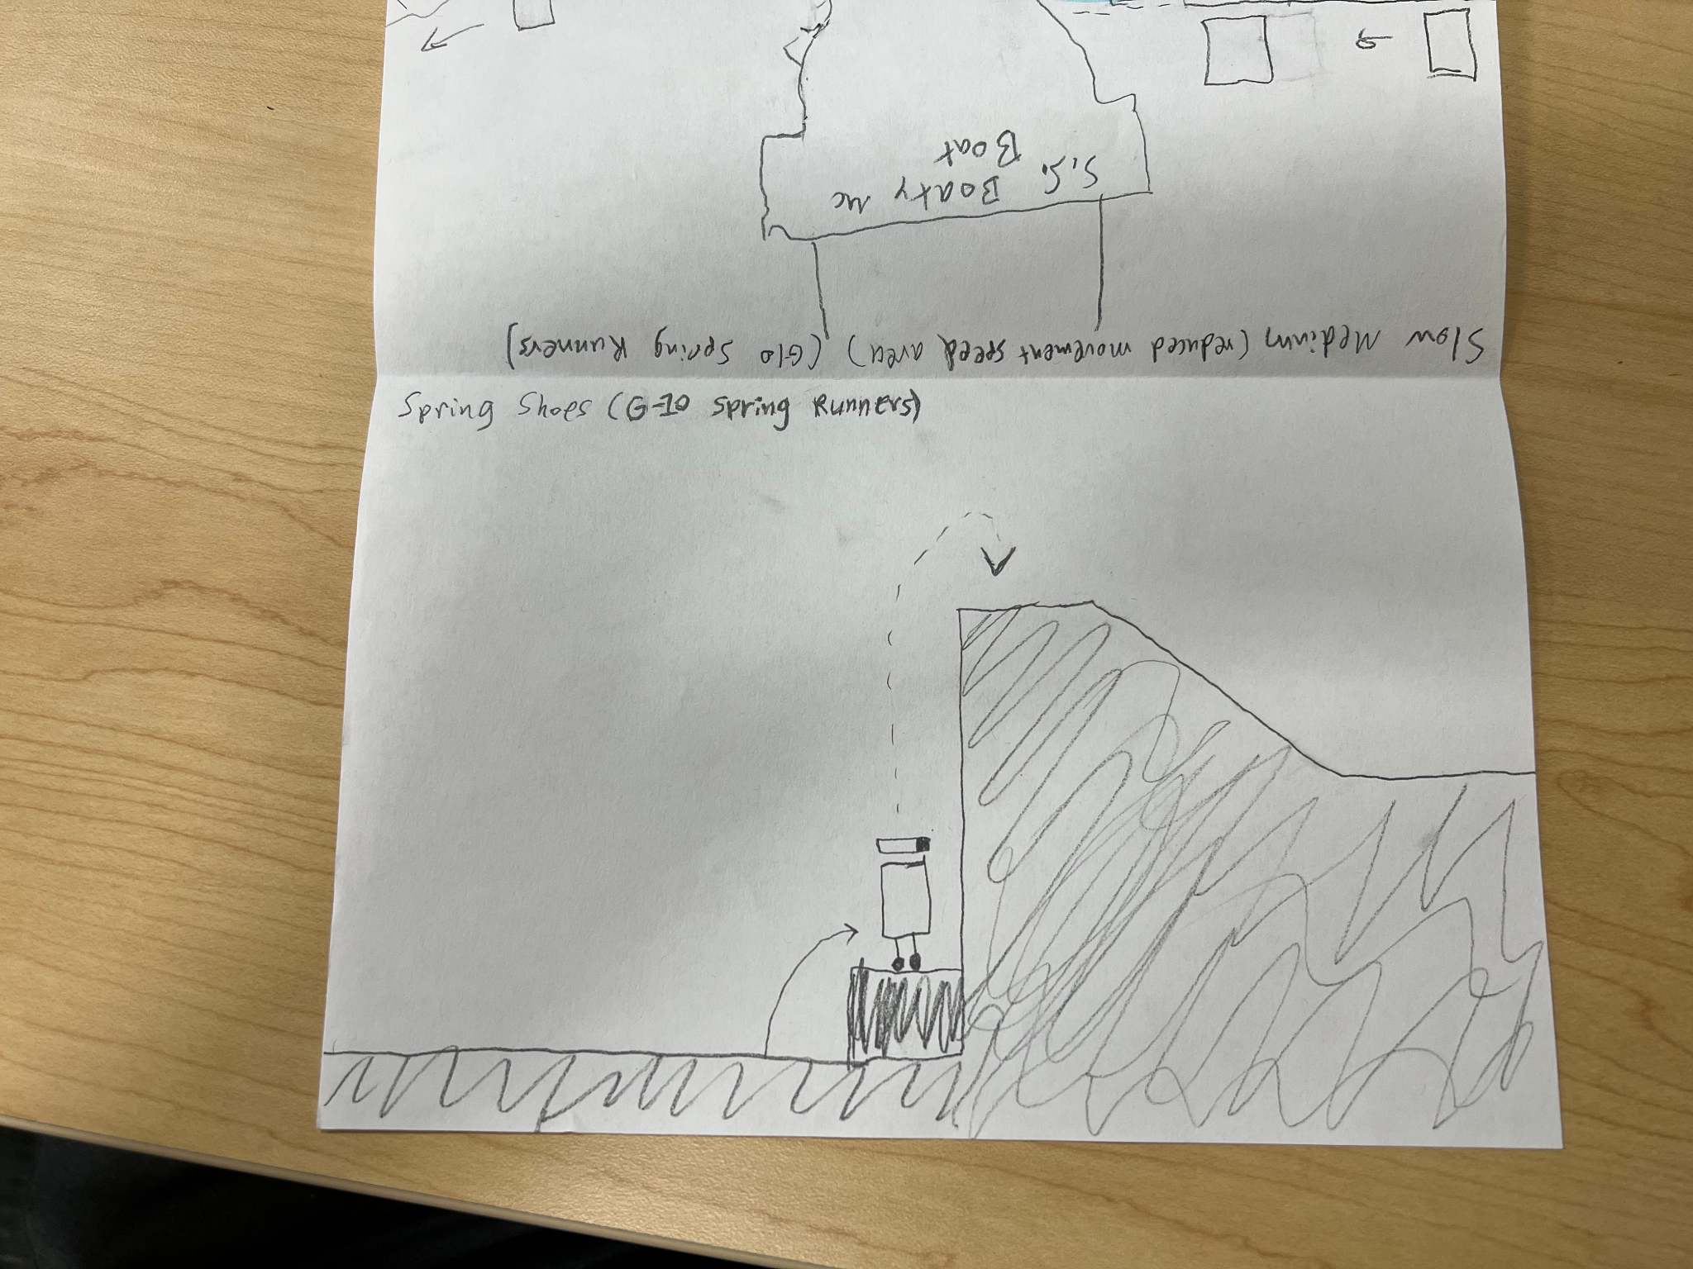

Slow medium (e.g., slow movement through a fluid) - Jeff

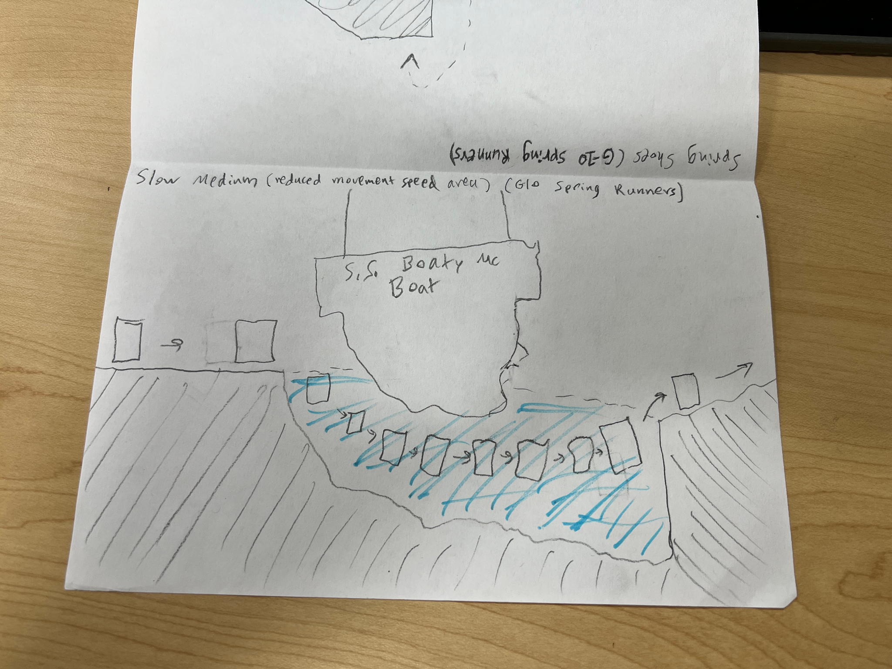

Boss fight (ending)

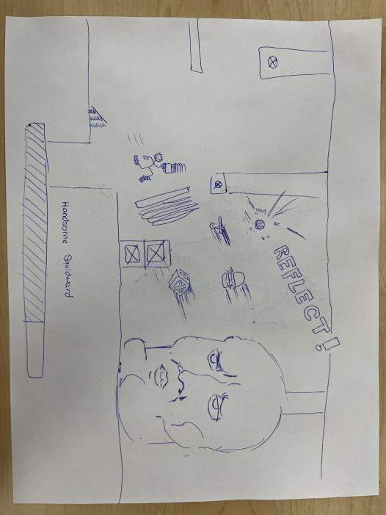

Intro/Tutorial jump mechanic (1) and spring shot grapple mechanic (2)

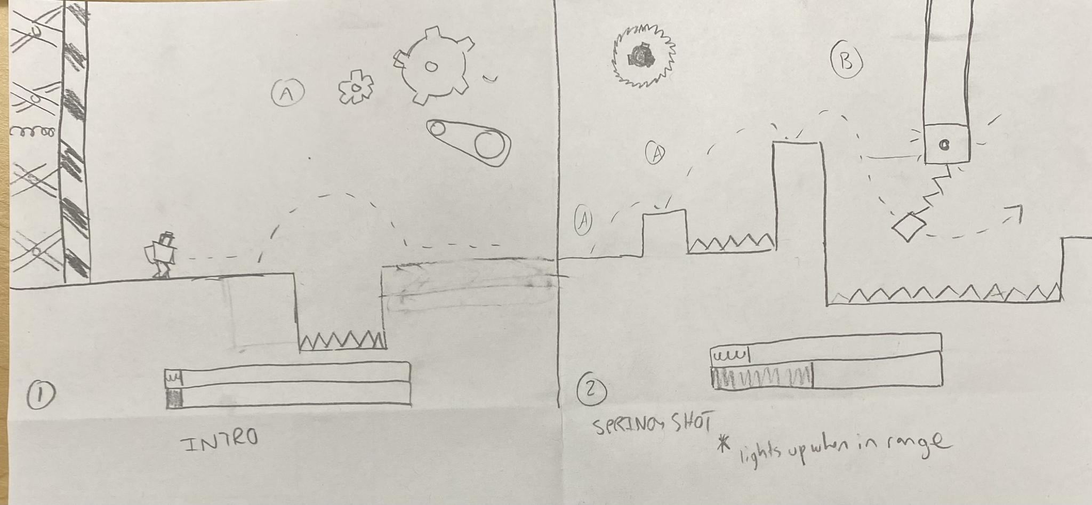

Bossfight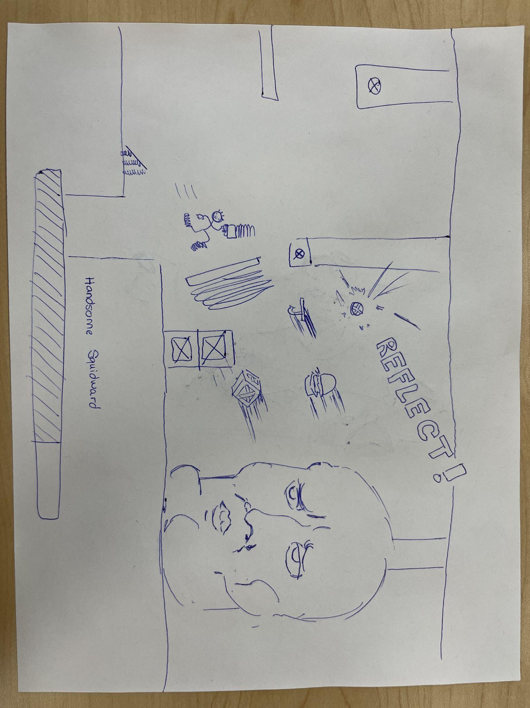

### 4-21 DevLog

Dev Log Components

1. What was done (previously):

Paper prototypes for game mechanics.

1. What each person is working on:

Create a demo (digital Prototype) for the corresponding items (in mechanics section below).

Placing their webGl builds of their [digital prototypes here](https://docs.google.com/document/d/1zhT4ndEIJq6tao2P65J2a3nizZxaowmg-A-oM4va0p0/edit).

Will work to have a partially (or better) functional prototype by class Wednesday (4/26).

1. Ideas on the backlog

Consult [Brainstorming (dev log 4-17)](https://docs.google.com/document/u/0/d/10YbR7ZwsOdTJEAQh0_UxB0a4T6fVfdVlN1q6NilfWPQ/edit)

1. Play testing analysis

n/a

1. Obstacles blocking development

None yet.

1. Reflection on game and process

Going well so far. Considering how different mechanics would interact with each other in game has been very interesting to consider. Especially, the challenge of considering how a new mechanic would interact with existing (and especially core) mechanics.

Mechanics:

(normal) Jump and Spring shoes - Jeffrey

Spring shot (swing and sling) (Malachi)

Boss Fight - Joseph

Wall of springs and progress bars (Lawrence)

Backlog mechanics:

Slow medium(slow fluid)

Slow floor / fast floor

### 4-24 DevLog

**Dev Log Components**

1. What was done (previously):

Paper prototypes for game mechanics. Working individually on digital prototypes.

1. What each person is working on:

Worked a bit on digital prototypes

Create a demo (digital Prototype) for the corresponding items (in mechanics section below).

Placing their webGl builds of their [digital prototypes here](https://docs.google.com/document/d/1zhT4ndEIJq6tao2P65J2a3nizZxaowmg-A-oM4va0p0/edit).

Will work to have a partially (or better) functional prototype by class Wednesday (4/26).

1. Ideas on the backlog

Consult [Brainstorming (dev log 4-17)](https://docs.google.com/document/u/0/d/10YbR7ZwsOdTJEAQh0_UxB0a4T6fVfdVlN1q6NilfWPQ/edit)

1. Play testing analysis

n/a

1. Obstacles blocking development

None yet.

1. Reflection on game and process

Good so far, the digital prototypes we saw today have been looking pretty good. Excited for wednesday.

### 4-26 DevLog

**Dev Log Components**

1. What was done (previously):

Working individually on digital prototypes.

1. What each person is working on:

Reviewing what we have so far for digital prototypes. Determining as a team what changes and tweaks make the most sense to fit our project. Making adjustments to play style.

1. Ideas on the backlog

Consult [Brainstorming (dev log 4-17)](https://docs.google.com/document/u/0/d/10YbR7ZwsOdTJEAQh0_UxB0a4T6fVfdVlN1q6NilfWPQ/edit)

1. Play testing analysis

Technically not playtesting, but our team review went well overall. We had some good starts to prototypes, and had a good degree of agreement on what changes would be beneficial for the project.

1. Obstacles blocking development

None yet.

1. Reflection on game and process

Digital prototypes so far are looking good. Starting to see how these could come together to make a fun game.

### 5-1 DevLog

**Dev Log Components**

1. What was done (previously):

Working individually on digital prototypes.

1. What each person is working on:

Presenting digital prototypes. The prototype builds are [here](https://docs.google.com/document/u/0/d/1zhT4ndEIJq6tao2P65J2a3nizZxaowmg-A-oM4va0p0/edit).

1. Ideas on the backlog

Consult [Brainstorming (dev log 4-17)](https://docs.google.com/document/u/0/d/10YbR7ZwsOdTJEAQh0_UxB0a4T6fVfdVlN1q6NilfWPQ/edit)

1. Play testing analysis

Technically not playtesting, but classroom feedback for our prototypes was positive.

1. Obstacles blocking development

None yet. Next step is integrating our functionality, which seems like it will go fine based on how people have done their code, but there will likely be some surprises.

1. Reflection on game and process

Digital prototypes worked well, received positive feedback. Ready to integrate them, and approach having a functional alpha build.

# 

# 

# Alpha Playtest (5/1 - 5/8)

## Jeffrey (12.5 Hrs total)

### 5/1-5/8 [2.5 hrs] (In class and in team meetings)

Team meetings and in class. Talked about plans going forward with level design, camera zoom, and tweaking movement.

### 5/2 - 1 hr (cum total 3.5 hrs)

Setting up Master Dev log components, documents, links; Working on DevLogs.

### 5/3 - Team meeting details (time already accounted for)

1 hour meeting, time accounted for in meeting time summary at top of this sub-section

Spent the first hour of class integrating camera follow and the piston into my build. So we now have jump, spring shoes jump, a basic version of piston in one build.

Group discussion, current rough plan: *future update, plan has been modified. Now is tutorial + everyone makes an example level

**Level 1**

jump

swing

**Level 2**

fast/slow area intro…?

**Level 3 (boss level? / enemy intro)**

**Level N (Boss level) (maybe separate, maybe not from Level 3)**

Blocks thrown at player, taking damage...

Platforming while fighting boss?

Potentially ending piston?

### 5/5 - 5.6 hours (cumulative time 9.1 hrs)

Primary focus today was integrating features from prototypes into the Alpha build.

Picked up from 5/3, with the build of movement, and basic piston.

Added / improved/ fixed the following features:

* Tutorial Info (having text explaining controls, and informing players). I created these.
* Modifying level design to have room for extra features
* Improving piston to have full functionality (integrating the following features from Lawrence)
  + Death animation + effect
  + Keeping piston on screen
* Grapple swing mechanics. Base grapple code from Malachi, many integration changes needed with both of us working on getting it working
  + Many involved steps and connections to get this working properly with existing hero movement
    - Debugging on Malachi’s project files
    - Moving it over
    - More debugging within alpha project

Finally, about 10 minutes documenting results of today

### 5/6 - 1.2 hrs (cumulative time 10.3 hrs)

I worked for approximately 1 hour on my level design today. I created a new scene in Unity and built a level in it. The actual level building now that we have our components placed in and working from the tutorial level, made building the level quite easy.

We will all end up building a scene of our own. This will make it so we can get feedback from different level design styles across the team, to see what aspects of each level people liked and didn’t like.

Also built and uploaded a new WebGL build of tutorial level. We should try and figure out how to do all the scenes in WebGL Build if we can.

Overall, a pretty good introduction scene, my only current consideration is if I want to make my top path that is currently impossible, and make it difficult but doable. Depending on how we build out the rest of the game, and how long we make levels will likely influence what ends up making the most sense there. If it is something like super meat boy with many deaths but quick respawns for relatively quick levels, that is an approach that could work if we decide, and get feedback supporting a move in that direction.

### 5/7 - 1 hr (cumulative time 11.3 hrs)

I built a Level Selection System. Currently, each level is accessed from the level select screen, with text saying what number to press for which level. I did the setup for it to go into those scenes. Making mostly blank scenes for the level that aren’t done yet.

Updated WebGL Build. Also spent a little time adding and labeling more fields on the Development Time Sheet, so each section of the project (based on Canvas assignment milestones) has spaces to have an entry for all we will need.

This version is pretty good now as an alpha. Will be much better for playesting, because now only 1 build is needed. The player just needs to close the window on death/victory, but can play all levels from the same WebGL Build.

### 5/8 - Class meeting + individual work .2 hr (cumulative time 11.5 hrs)

//Class meeting work time for the game: 1.5 hours (accounted for at top of sub-section)

Some time cleaning up documents, and adding documentation for some of the playtesting into our internal team documents before the playtest.

### 5/9 - 1 hr (cumulative time 12.5 hrs)

Spent some time going through feedback, considering what was more optional feedback, and which items were bugs / features that we mostly already knew we would need for the future versions like actually having death/victory handling. Also did include some feedback though that was consistent among many of the playtesters that we weren’t expecting, so will address those also.

Updated master DevLog and connected in the appropriate documents used in gathering and evaluating the feedback we received.

## Malachi [9.5 Hours Total]

### In Class [2.5 Hours]

Team meetings and in class. Talked about plans going forward with level design, camera zoom, and tweaking movement.

### 5/5 [5 Hours]

Worked with others to get grapple mechanic fully integrated, otherwise just bug fixes, and compiling all our individual parts together into a single build. See 5/5 - 5.6 hours (cumulative time 6.6 hrs) for more information on what the team worked on.

### 5/8 [2 Hours]

Worked on level design building level for alpha levels.

## Lawrence [11 hours]

### 5/3 [1 hour]

Spent the first hour of class integrating camera follow and the piston into Jeffrey’s build with the normal jump and spring jump.

### 5/5 [5 hours]

* Worked on changing Piston Mechanics so that it would always appear on the left side of the screen even if you outran it.
* Did a lot of general debugging especially when working on integrating all of the features into one build.
* Worked on integrating the death animation into the main build.

### 5/7 [5 hours]

Worked on creating my platforming level for the game. I also played around with changing the physics of the grapple so that the transition from flying to grappling and from grappling to release would be smoother.

## **Joseph [10.5 Hours of Work]**

### May 1st - May 8th [2.5 hrs] (In class and in team meetings)

Team meetings and in class. Talked about plans going forward with level design, camera zoom, and tweaking movement.

### May, 5th [5 hours]

Note: much of this ideating was done before this date in preparation for the actual creation of this artwork, which are an uncountable amount of time that exceeds one hour

Keeping in mind that there was a limited amount of time to come up with a guiding style for the game and to develop it and then create assets that fit into it; I focused on creating core assets in the same session to create a cohesive style.

Much of this time was spent looking at inspiration and doodling on paper until I had something I liked the look of. At this point, because the other developers are working on merging our mechanics and have run into some unforeseen difficulties It makes the most sense to create a set of spritesheets for the player and a basic background.

This meant that I needed to identify the possible states of the player: idle, running (with or without directions?), a jumping and grappling state. This would be a lot of different sheets to make; but from my prior experience with the unity editor I was aware of an inbuilt state machine and spent most of this time working on the sprites in each sheet. Not much more to say about that; it was a lot of drawing, erasing, and redrawing.

Once my sprite sheets were created after a few hours I decided, since we all agreed upon it being the prime motivating force in our game for the player to pursue the end-goal, I made a simple yellow caution tape styled prototype asset.

### May, 7th [3 hours]

Since the art was done, all that needed to be done was creating the state machines and integrating the necessary parameters adjusting transitions in state into the movement logic implemented by my fellow teammates. This took around an hour and a half.

After I had completed the art, it was necessary to create a way for the prototype featuring the art I made was publicly accessible and implemented properly. This was surprisingly difficult due to conflicts created by versions of our source on github and access to them.

These issues were eventually resolved when I decided to copy the files of the unity project from the main alpha repo into a new cloned repository of my own to build and publish a working version of the build that included the art for playtesting. This meant that there was a second link to host this build unfortunately.

# Beta Playtest (5/8 - 5/15)

***At this point, in-class / team meeting are placed within DevLog sections (for ease of managing when one person needed to skip or arrive late to a meeting)***

## Jeffrey (8.5 hrs total)

### 5/10 - 1 Hour individual + 1 hours team meeting (2 hrs)

1 hour outside of class to be accounted for in the Beta Build time. Also had the hour in class which is not being counted here, and is counted under the devLog for 5/10…

* Fixed standing on textbox bug (in class work time)
* Added in items to my scene (for death/respawns when falling off) (in class work time)
* Made <space> work to jump. Also can still use W (at home)
* Integrated my work with Lawrence’s changes (at home)

### 5/11 - 2 hrs (Cumulative Time 4 hrs)

Primary items worked on:

* Getting website placed into docs folder so it can be live.
* Fixing small things on the website so it words as expected
* Merging + integrating project branches, resolving the conflicts that came up
* Updating documentation (ReadMe, MasterDevLog…) & Organizing team files

### 5/14 - 1.5 Hrs (Cumulative Time 5.5 hrs)

Primary Items worked on:

* Integrated Lawrence files branch with main branch
* Added tiled background to my scene (level)
* Replaced WebGL build
* Added a link to class document pointing to our website so WebGL Build can be accessed
* Documentation for Beta Playtest

### 5/15 - 1 hr individual + 2 Hr in class (Cumulative Time 8.5 hrs)

Primary Items worked on:

* Reviewing team files
* Cleaning up team documents
* ‘Playtesting’ our Beta build by myself (trying to find any bugs)

Overall, reviewing everything, making sure it all looks ready for the in-class playtesting later today.

Then true Playtesting in class, about 2 hours, got lots of great feedback from our classmates

## Malachi

### 5/10 [2 Hours]

Worked on level design and changed physics to be a bit faster and responsive feel of player movement, but retained similar max jump distance and height.

## Lawrence [11 hours]

### 5/10 [5 hours]

I spent the first hour of class working on a pause screen and adding a “play again” button. After class, I spent four hours creating the main skeleton of the website with space to put all of the final deliverables such as the trailer, screenshots, and all of the documentation.

### 5/13 [5 hours]

* Fixed the level select screen from being zoomed in too much and cutting some of the text off by tinkering with the camera and canvas settings
* Added a pause menu and death menu
* Fixed bug where dying while grappling would cause the player to stay grappled instead of launched off screen
* Fixed bugs with pause and death menus

### 5/14 [1 hour]

Made changes to the layout of my level.

## **Joseph [8 Hours of Work]**

Note: Missed Class Time and Meeting due to a work obligation. Coordinated and communicated with the team prior in preparation for this trip 10 - 17th.

### May, 14th [8 hours]

Note: much of this ideating was done before this date in preparation for the actual writing of the code on this date. I was confident in my ability to actualize the design that I was building in one session. I work in these long-houred bursts of time to accommodate my work and school schedule.

Based on a discussion I had with my teammates in class on the 8th before my trip to do network engineering work for a tech trade show SAP Sapphire in Orlando, Florida; we wanted to test out some different controls and method of traversal for our level. I would spend time while away at this work event that I had to do to build a new version of our game that fit some of the design elements that I thought would help our game succeed.

I argued that a constantly moving player, regardless of player input, would allow the player to derive more enjoyment from landing precise jump timings and grapples accompanied by a boss where a click-timing-event would do damage to the boss.

I essentially re-programmed every aspect of our game from the ground up on my laptop at work in any time I could squeeze out. The entire movement script, obstacle interaction in accordance with constant player movement (which proved to be a difficult design problem and challenge to implement effectively), and an adjustable height jumping mechanic that is meant to be more intuitive.

After a lot of coding and trying different speeds over and over again, and adjusting the jump height to match how long the player holds down the jump button (release to jump). I spent copious amounts of time setting up proper folder structure for us to potentially build off of the new prototype if we choose to follow feedback.

Finally, I spun up a WebGL build for the new version of the game within our repository in its own directory. I did not push the game code, since we did not decide if we are moving in this direction or not.

# PostMortem Presentation (5/15 - 5/24)

## Jeffrey (14 hrs total)

### 5/17 - 4.0 hours (inc. team meeting)

**Pre-Team meeting (1.75 hrs)**

General Items:

* Fix build settings to include all projects again
* Build a new Jeff Scene
  + Transfer over Lawrence Level so I have a base
  + Remove some of the Lawrence level items so they aren’t the same
  + Modify some of the lawrence level items sufficiently that even though they may look similar, they require a different strategy
  + Add more alternate and partial paths (shortcuts/ diff routes)
* Work on documentation

**Team Meeting (1.5 hrs)**

General items:

* Working with team on planning next steps
* Debugging the grapple glitch (solution, you must have the camera attached to the grapple script in hero)
* Prepared final project repository

**Post-Team meeting (0.75 hrs)**

General items:

* Documenting what was done earlier today
* Reviewing, merging, updating team documentation and project files.
* Working with Malachi on a pull request to get his levels into the main build
* Updating Repo documentation to work properly post changeover to final repo.

### 5/18 - 1 hr (5.0 hrs cumulative total)

* Create the modified background (removing the floor), have it tile properly.
  + It is ready to copy.
* Create a working hero art
  + It is ok, probably needs to be tuned a bit better (sizing wise), but it is functional
* Created and uploaded a new WebGL build

### 5/19 - 2.5 hrs (7.5 hrs cumulative total)

**Team Meeting (1.5 hrs)**

* Fixed grapples on my level so they now all show ropes instead of just bottom ones
* Formed plan for the next few days with team
* Made other smaller fixes to my level

**Post Meeting Work and Wrapup (1 hr)**

* Draft ideas for postmortem presentation (all 10 ideas filled in, likely to be updated with team later)
* Reviewed + fix up the end of my level (and made the top path doable
* Document the work done today

### 5/20 - 1 hr (8.5 hrs cumulative total)

Primary Tasks worked on today:

* Fixing Level select screen to have all the current levels, cleaning up that UI, code…
* Producing new WebGL Build
* ‘Playtested’ the game a bit myself
* Made more fixes to my level (death for falling off, changing text…)

### 5/22 - 2.75 hrs (11.25 hrs cumulative total)

**Team Meeting 1.5hrs**

* Worked with team as described in [this document](https://docs.google.com/document/d/1SStpNSxdsv39urpQl0IzfhVBRfz5YBDHyAUpZKaTpfQ/edit)
  + …but, primary tasks were:
    - Planned what people will be working on later today (to be ready for playtesting Tuesday (tomorrow)
    - Post mortem presentation
    - Developed Google Form to guide playtest

**Individual work 1.25 hr**

* Added button functionality to the level select
* Added a background, added the hero, aligned and expanded the textboxes to create a more visually appealing and effective level selection screen
  + Leaving the player with a much better initial impression than before the change
* Trying to fix the player not making the entire loading screen visible properly
* New WebGL Build
* Updated ReadMe on GitHub page to more accurately reflect the current state of our game

### 5/23 - 2.5 hrs (13.75 hrs cumulative total)

**Trying to work on Merge 1 hr**

* Looked through the repo, got it worked out to at least mostly work properly

**Meeting to review merge 1 hr**

* Review with Joseph (and briefly Lawrence) going over the merge
* Overall, we found the merge to be relatively successful considering the situation, to the best of what we could tell, all the functionality was there after the manual merge
* Also made some other small tuning changes
* Created a new WebGl build in test build

**Wrapping up, documenting .5 hr**

* Wrote and updated documentation for today
* Prepared for and reviewed Postmortem Presentation

### 5/24 - 0.25 hrs (14 hrs cumulative total)

* Review game build
* Added the link to read me page
* Reviewed postmortem presentation

## Malachi [15.5 Hours Total]

### 5/18 [1 Hour]

Facilitated playtesting with 1 other person.

### 5/19 [1 Hour]

Team meeting, shared the current state of the project and formed a plan for the next few days.

### 5/21 [5 Hours]

Composed music for the game and created 2 .wav files of the songs to be added to the unity project.

### 5/22 [5.5 Hours]

Team Meeting [1.5 Hours]

Worked with team as described in [this document](https://docs.google.com/document/d/1SStpNSxdsv39urpQl0IzfhVBRfz5YBDHyAUpZKaTpfQ/edit)

* + Planned what people will be working on later today (to be ready for playtesting Tuesday (tomorrow)
  + Post mortem presentation
  + Developed Google Form to guide playtest

Sound Design [4 Hours]

-Sound effects

-Song design

-Implementing sounds and songs into the unity project

### 5/23 [3 Hours]

Additional work on sound effects, facilitated playtesting with others.

## Lawrence [15.75 hours]

### 5/18 [2 hours]

* Made victory screen and quit screen
* Updated the colors of the grapple block and circle both when idle and when in radius

### 5/19 [5.5 hours]

Team Meeting (1.5 hours): Formed the plan for the next few days with the team.

Post Meeting (4 hours): First, I created the platforming section of the boss level. After that, I tinkered a bit with the death animation so that there was a shortened delay between being launched off screen and the screen shaking.

### 5/21 [3.75 hours]

* Imported the prototype boss functionality into the boss level
* Created the enemy that shoots projectiles and implemented it into the boss level
* Playtested and tweaked the boss level

### 5/22 [4.5 hours]

Team Meeting (1.5 hours)

Solo Work: Worked more on the boss level. First, I worked on tuning the enemy projectile speed and fire rate as they were too fast. Then, I added a checkpoint at the place in the level where the boss spawns in. Lastly, I created the boss’ new attacks.

## **Joseph [15 Hours of Work]**

Note: Missed Class Time and Meeting due to a work obligation. Coordinated and communicated with the team prior in preparation for this trip 10 - 17th.

### May 19th [5.5 hours]

Formed the plan for the next few days with the team in a meeting. Ideated and spent time researching potential artwork for the enemy/boss projectiles.

### May 21st [4.5 hours]

Team Meeting 1on1 where I assisted teammates with importing my boss functionality from my testlevel into the boss level and creating an enemy that shoots projectiles. Continued to independently work on the final boss sprites and state-machine.

### May 22nd [5 hours]

Team Meeting

Spent individual time creating the box and projectile assets

# Game Presentation (5/24 - 5/31)

## Jeffrey (6.5 hrs total)

### 5/25 - .25 hrs

* Facilitated Playtesting with 1 person

### 5/26 - .50 hrs (0.75 hrs cumulative total)

* Facilitated playtesting with 2 more people

### 5/27 - 1.75 hrs (2.5 hrs cumulative total)

* Prepared “Final Playtests Data + Analysis” file
* Reviewed Playtest feedback, found things in my scene to fix, documented them in the “Final Playtests Data + Analysis” file, fixed them
* Cleaned up readme file
* Updated WebGL situation
  + Old builds moved into one old build folder
  + New build into a different folder, and website link updated
* Other miscellaneous file cleanup, organization, and Documentation work

### 5/29 - 2.25 hrs (4.75 hrs cumulative total)

* Team Meeting (2hrs)
  + Work on Game presentation (went 0 to complete*)
    - Except having the correct trailer in
  + Planning an outline and finding inspiration for the trailer
  + Discussing website layout ideas
  + Planning for between now and Wednesday
  + Initial discussions of how we will move from what we have now into final deliverables
* Documenting (15 minutes)
  + Reviewing the tasks we did, basic proofreading, checking for flow
    - Overall, was quite good
  + Writing this to give some notes on the items we discussed

### 5/31 - 1.75 hrs in class (6.5 hrs cumulative total)

Class Game Presentations

* Presented our game
* Listened to other game presentations to better understand their games before reviewing them
* Reviewed other team’s games

## Malachi [6 Hours Total]

### 5/29 [3 Hours]

Recorded game footage, created and edited game trailer to be shared in presentation. Got feedback from group members on what to add, remove, and change about the trailer.

### 5/30 [3 Hours]

Finished editing the trailer with feedback and collaboration from all other group members. Presented the trailer in class as a part of the game presentation the next day.

## Lawrence [12.5 hours]

### 5/24 [2 hours]

Conducted playtests with several people over the course of the day.

### 5/27 [2.5 hours]

Implemented the new boss code with the checkpoint, enemy fire rate change, and the new boss attacks into the main WebGL build.

### 5/28 [3 hours]

* Various tweaks and bug fixes
  + Changed some of the tutorial text
  + Removed the boss from the tutorial
  + Switched level 1 and 2
  + Offset the piston so that it is visible on the screen
  + Changed the text of the main menu
  + A lot of other stuff I know I did but forgot

### 5/30 [5 hours]

* Helped Malachi with editing the game trailer
* Made a few small bug fixes to the game as well as tweaked the speed of the wall of springs in various levels
* Updated the website by implementing a new layout, adding new features such as a toggleable sidebar, and created the “About” page

## **Joseph [6.5 Hours of Work]**

### May 24th [2 hours]

Implemented the remaining art assets.

### May 29th [2.5 hours]

Team Meeting where we completed the presentation deliverables aside from the trailer which we delegated to a group member who was absent from the meeting.

### May 30th [2 hours]

Assisted in the trailer creation with teammates.

# Final Deliverables (5/31 - 6/4)

## Jeffrey (5.25 hrs total)

### 6/2 [2.25 hrs Team Meeting + .75 individual (cumulative total 3 hrs)]

Team Meeting (team efforts)

* Create [final deliverables status](https://docs.google.com/spreadsheets/d/1mUgRGdFHS2HLhK6_qgcqj4Oaq8K5l9iT16Gm2Zsc8t0/edit#gid=0) resource
* Team reflection - create it, revise, build up to final version
* Update website to have access to the resources we already have completed
* Getting on the same page for how we will deliver the DevLogs
  + Resulting in the decision to be in the format of this document

Individual work

* Document the work for today
* Copy the entries data from my previous DevLogs over to this complied DevLog (all previous ones except for Digital Prototype era items)
* Other miscellaneous document formatting and review

### 6/3 - 2.25 hrs (5.25 hrs cumulative total)

* Put in my specific items in for Digital Prototypes (individual work sections)
* Coordinated to final plan for how we will do digital prototypes with the team over discord
* Copied over and re-formatted the daily group logs into the Overview/Summary sections
  + Fixed the times on the Development TimeSheet adjusted to meet the format of how we are doing it now
* Documented the work for today

## Malachi [4 Hours so far]

### 6/2 [2 hours with group + 2 hours alone]

Worked on team reflection, filled in final devlog, met with team to decide on how to finish up final deliverables.

## Lawrence [However long its taken to get the final deliverables done lol I haven’t been keeping track]

### 6/2 - 6/4 [At least 4 hours]

After the game presentation, the group has solely been focusing on completing the final deliverables. I have been filling out my part in the final development log and have been in charge of updating the website to include all of the final deliverables.

## **Joseph [3 Hours of Work]**

### June 2nd [2 hours]

Met with the group to discuss remaining necessary documentation.

### June 3rd [1 hour]

Completed remaining work.

## 